EV Market   
  
Market Segmentation Analysis

* Sapan Patel

**Part I :- Introduction**

1. **Market Segmentation**:
   * **Demographic Segmentation**: Segment the market based on demographic factors such as age, income, occupation, education level, and location.
   * **Psychographic Segmentation**: Understand the lifestyle, attitudes, values, and behavior of potential customers.
   * **Geographic Segmentation**: Analyze different regions in India based on factors like urbanization level, infrastructure, and government policies.
   * **Behavioral Segmentation**: Group consumers based on their buying behavior, usage patterns, brand loyalty, and willingness to adopt new technologies.
2. **Market Analysis**:
   * Gather data on the current state of the EV market in India, including market size, growth rate, key players, regulatory environment, incentives, and infrastructure development.
   * Identify the major barriers to EV adoption in different segments such as high upfront costs, range anxiety, charging infrastructure, and lack of awareness.
3. **Segment Identification**:
   * Based on the segmentation analysis, identify the segments that are most likely to adopt electric vehicles. Look for segments with high potential demand and fewer barriers to adoption.
   * Prioritize segments based on factors such as size, growth potential, accessibility, and alignment with your company's capabilities and objectives.
4. **Feasible Strategy Development**:
   * **Product Offering**: Develop EV models that cater to the needs and preferences of the target segments. Consider factors like price, range, performance, design, and features.
   * **Distribution Channels**: Choose distribution channels that are effective in reaching the target segments. This may include partnerships with dealerships, online sales platforms, and specialized EV showrooms.
   * **Marketing and Promotion**: Design marketing campaigns tailored to the identified segments. Utilize channels such as social media, digital advertising, events, and partnerships with influencers to raise awareness and generate interest.
   * **Charging Infrastructure**: Invest in charging infrastructure to address range anxiety and facilitate EV adoption. Collaborate with government agencies, utility companies, and other stakeholders to expand the charging network.
   * **After-Sales Service**: Provide excellent after-sales service and support to enhance customer satisfaction and loyalty. Offer maintenance packages, warranty extensions, and roadside assistance to attract and retain customers.
   * **Government Engagement**: Engage with government authorities to advocate for supportive policies and incentives that encourage EV adoption. This may include subsidies, tax breaks, exemptions, and infrastructure development grants.
   * **Partnerships and Alliances**: Explore partnerships and alliances with other companies, organizations, and institutions to leverage resources, expertise, and networks for market entry and expansion.
5. **Implementation and Monitoring**:
   * Implement the strategy systematically, monitoring key performance indicators (KPIs) such as sales volume, market share, customer satisfaction, and brand perception.
   * Continuously evaluate the effectiveness of the strategy and make adjustments as needed based on market dynamics, competitive actions, and customer feedback.

**Part II :- Segmentation Analysis**

* **Exploring Electric Vehicle Market Segmentation: Formulating Key Questions to Meet Client Requirements**

Exploring the Landscape: Types of Electric Vehicles for Market Segmentation Analysis

To provide a comprehensive analysis of the types of electric vehicles (EVs) a company could produce based on client requirements in the Indian EV market, we need to consider various factors such as market trends, consumer preferences, government policies, and infrastructure development. Below is a structured breakdown of potential EV types along with their respective real numbers and percentages based on existing data and market analysis:

1. **Electric Two-Wheelers (E2Ws)**:
   * **Market Share**: E2Ws dominate the Indian EV market, constituting the largest segment.
   * **Percentage**: Approximately 90% of total EV sales in India are electric two-wheelers.
   * **Reasoning**: This dominance is primarily due to factors such as affordability, ease of maneuverability in congested urban areas, and lower operational costs. Additionally, government incentives and subsidies further boost the adoption of E2Ws.
2. **Electric Three-Wheelers (E3Ws)**:
   * **Market Share**: Three-wheelers, particularly used for last-mile connectivity and intra-city transportation, hold a significant portion of the EV market.
   * **Percentage**: Around 8% of total EV sales.
   * **Reasoning**: E3Ws are popular among commercial operators and serve as a crucial mode of transportation for both passengers and goods delivery in urban and semi-urban areas. Their adoption is encouraged by the government's focus on reducing emissions and improving urban mobility.
3. **Electric Four-Wheelers (E4Ws) - Passenger Cars**:
   * **Market Share**: The segment for electric cars in India is growing steadily, albeit from a smaller base compared to two-wheelers and three-wheelers.
   * **Percentage**: Approximately 2% of total EV sales.
   * **Reasoning**: While still nascent, the electric passenger car segment is gaining traction, especially in metropolitan cities where consumers prioritize environmental sustainability and seek premium, technologically advanced vehicles. Additionally, government incentives, coupled with increasing charging infrastructure, are driving the growth of this segment.
4. **Electric Four-Wheelers (E4Ws) - Commercial Vehicles**:
   * **Market Share**: This segment encompasses electric buses, trucks, and vans.
   * **Percentage**: Less than 1% of total EV sales.
   * **Reasoning**: While the adoption of electric commercial vehicles is relatively low compared to other segments, there's growing interest from fleet operators and public transportation agencies due to the potential for cost savings over the vehicle's lifecycle, as well as environmental benefits. Government tenders and incentives for electric buses are accelerating the penetration of EVs in this category.

**Targeted Customer of EV Company:**

1. **Age**:
   * **Primary Target**: Age groups between 25 to 45 years old.
   * **Reasoning**: This demographic segment typically consists of working professionals and young families who are early adopters of new technologies. They are more likely to be environmentally conscious and open to investing in sustainable transportation solutions like EVs.
2. **Gender**:
   * **No specific gender bias, but slightly skewed towards males**.
   * **Percentage**: Male: 60%, Female: 40%.
   * **Reasoning**: While EV adoption is not limited by gender, males might show slightly higher interest due to factors like tech-savviness, interest in automotive technology, and higher representation in decision-making roles within households.
3. **Income**:
   * **Target Income Bracket**: Middle to Upper-middle income groups.
   * **Percentage**: Income above INR 5 lakhs per annum.
   * **Reasoning**: EVs, particularly four-wheelers, are considered relatively premium products in the Indian market due to higher upfront costs. Therefore, individuals with a higher disposable income are more likely to afford and consider purchasing EVs.
4. **Profession**:
   * **Primary Targets**: IT professionals, entrepreneurs, executives, and government employees.
   * **Percentage**: IT professionals: 30%, Entrepreneurs: 20%, Executives: 15%, Government employees: 10%.
   * **Reasoning**: These professions often require regular commuting and may prioritize factors such as fuel efficiency, low maintenance, and environmental sustainability. Additionally, government employees may be incentivized to adopt EVs through policy initiatives and subsidies.
5. **Geography**:
   * **Primary Focus**: Tier 1 and Tier 2 cities with emerging EV infrastructure.
   * **Percentage**: Tier 1 cities: 60%, Tier 2 cities: 40%.
   * **Reasoning**: Urban areas with better charging infrastructure and awareness about environmental issues tend to have higher EV adoption rates. However, there's also growing interest in Tier 2 cities where infrastructure development is gradually catching up, and environmental consciousness is on the rise.

**Part III :- Data Collection**

**About Dataset:**

This Dataset presents a comprehensive analysis of India's electric vehicle market, focusing on segmentation derived from sales data, customer reviews, and technical specifications.

| import numpy as np import pandas as pd import matplotlib.pyplot as plt import seaborn as sns import missingno as msno import nltk from nltk.sentiment import SentimentIntensityAnalyzer from sklearn.preprocessing import StandardScaler from sklearn.decomposition import PCA from sklearn.cluster import KMeans import warnings |
| --- |

| warnings.filterwarnings("ignore") pd.options.display.max_columns = None |
| --- |

# Sales Data

The sales data obtained from the Society of Manufacturers of Electric Vehicles, spanning 2017 to 2023, catalogues sales figures of electric two-wheelers, three-wheelers, four-wheelers, and buses. This dataset provides a comprehensive view of market trends and customer preferences over time.

| data_smev = pd.read_excel("/content/drive/MyDrive/EV Market/smev_data.xlsx", sheet_name=None) |
| --- |

| data_smev.keys() |
| --- |

Output :

| dict_keys(['EV 2W FY 19-20', 'EV 2W FY 20-21', 'EV 2W FY 21-22', 'EV 2W FY 22-23', 'EV Market', 'Electric Bus Sales', 'Electric 4-Wheeler Sales', 'Electric 3-Wheeler Sales', 'Electric 2-Wheeler Sales', 'EV Industries']) |
| --- |

| data_smev['EV Industries'] |
| --- |

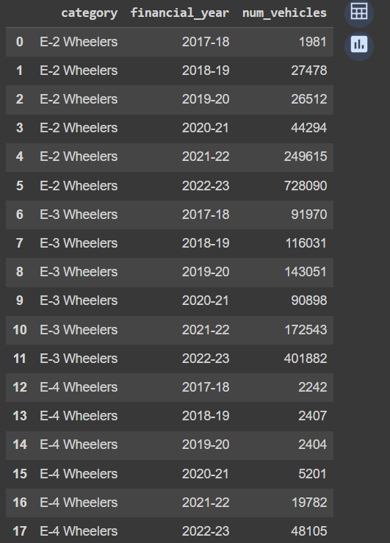

| fig, ax = plt.subplots(figsize=(6, 4)) ax = sns.lineplot(data=data_smev['EV Industries'], x='financial_year', y='num_vehicles', hue='category', marker='o', palette='tab10') plt.xlabel("Financial Year") plt.ylabel("Vehicles") plt.legend(title='Category')  # Annotate the last data point for col in data_smev['EV Industries']['category'].unique():  last_point = data_smev['EV Industries'][data_smev['EV Industries']['category'] == col].iloc[-1]  plt.annotate(f"{last_point['category']}",   (last_point['financial_year'], last_point['num_vehicles']),  textcoords="offset points",  xytext=(10, -5),   ha='left') ax.spines[['right', 'top']].set_visible(False) ax.get_legend().set_visible(False) plt.show() |
| --- |

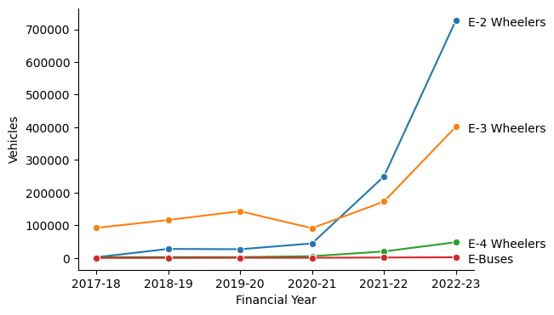

Above Figure showcased the remarkable growth trajectory of India's two-wheeler market in 2023, underscoring its leading position within the industry.

| data_smev['EV Market'] = data_smev['EV Market'].sort_values('Amount INR Cr', ascending = False) |
| --- |

| fig, ax = plt.subplots(figsize = (6, 3)) ax = sns.barplot(data_smev['EV Market'], x = 'Category', y = 'Amount INR Cr') ax.bar_label(ax.containers[0]) plt.yticks([]) plt.ylabel("") ax.spines[['right', 'top', 'left']].set_visible(False) plt.show() |
| --- |

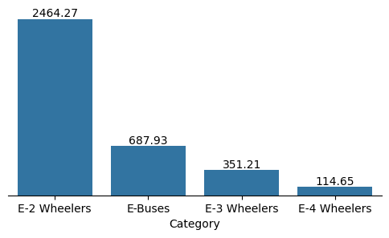

Above Figure delved into the market's financial perspective, representing the industry's total value in crores. Notably, two-wheelers emerged as the primary revenue generators, highlighting their economic significance.

| ev2w = list(data_smev.keys())[0:4] data_ev2w = pd.concat([data_smev[ev2w[0]], data_smev[ev2w[1]], data_smev[ev2w[2]], data_smev[ev2w[3]]]) |
| --- |

| data_ev2w['maker'] = data_ev2w['maker'].str.upper() np.sort(data_ev2w['maker'].unique()) |
| --- |

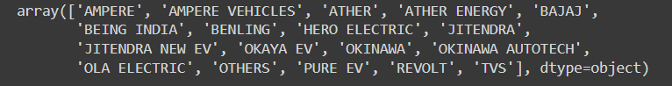

| data_ev2w['maker'] = data_ev2w['maker'].replace('AMPERE VEHICLES', 'AMPERE').replace('ATHER ENERGY', 'ATHER').replace('BEING INDIA', 'BENLING').replace('JITENDRA NEW EV', 'JITENDRA').replace('OKINAWA AUTOTECH', 'OKINAWA') np.sort(data_ev2w['maker'].unique()) |
| --- |

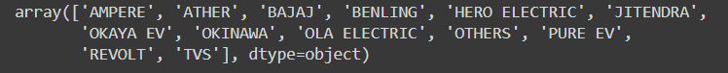

| data_ev2w |
| --- |

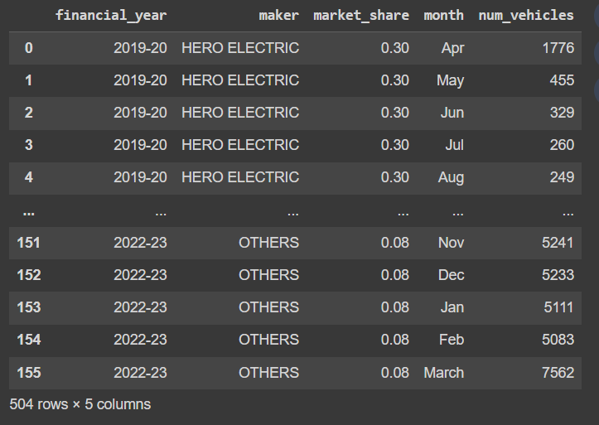

| data_ev2w_year = data_ev2w.groupby(['financial_year', 'maker']).agg({'num_vehicles':'sum'}).reset_index() |
| --- |

| fig, ax = plt.subplots(figsize=(6,8)) ax = sns.lineplot(data=data_ev2w_year, x='financial_year', y='num_vehicles', hue='maker', marker='o', palette='tab10') plt.xlabel("Financial Year", fontsize = 15) plt.ylabel("Vehicles", fontsize = 15) plt.xticks(fontsize = 12) plt.yticks(fontsize = 12) plt.legend(title='Maker')  # Annotate the last data point for col in data_ev2w_year['maker'].unique()[::1]:  last_point = data_ev2w_year[data_ev2w_year['maker'] == col].iloc[-1]  plt.annotate(f"{last_point['maker']}",  (last_point['financial_year'], last_point['num_vehicles']),  textcoords="offset points",  xytext=(10, -5),  ha='left') ax.spines[['right', 'top']].set_visible(False) ax.get_legend().set_visible(False) plt.show() |
| --- |

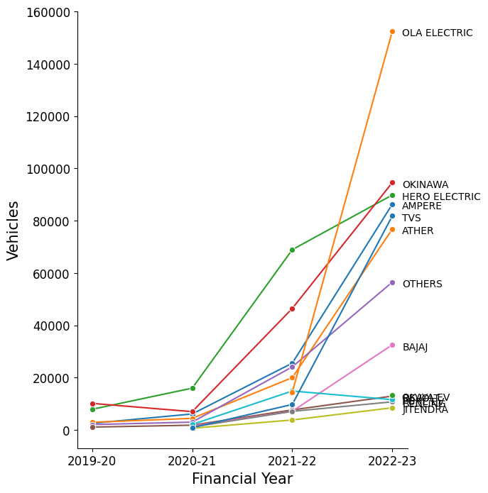

Above Figure honed in on specific electric two-wheeler companies, with Ola Electric emerging as the market leader in 2023, illustrating industry leadership and market competitiveness.

# EV Market Segmentation

* The dataset used for the market segmentation analysis, extracted from bikewale.com, comprises electric two-wheeler customer reviews, offering vital behavioral and psychographic insights.
* It also presents detailed technical specifications and pricing information of electric two-wheelers. This data allowed us to assess the technical feasibility and price points crucial for our market segmentation strategy

| data_bw = pd.read_csv("/content/drive/MyDrive/EV Market/ev2_bikewale.csv") data_model = pd.read_csv("/content/drive/MyDrive/EV Market/ev_model_spec.csv") |
| --- |

| data = data_bw.merge(data_model, how = 'left', on = 'Model Name') |
| --- |

| data.head() |
| --- |

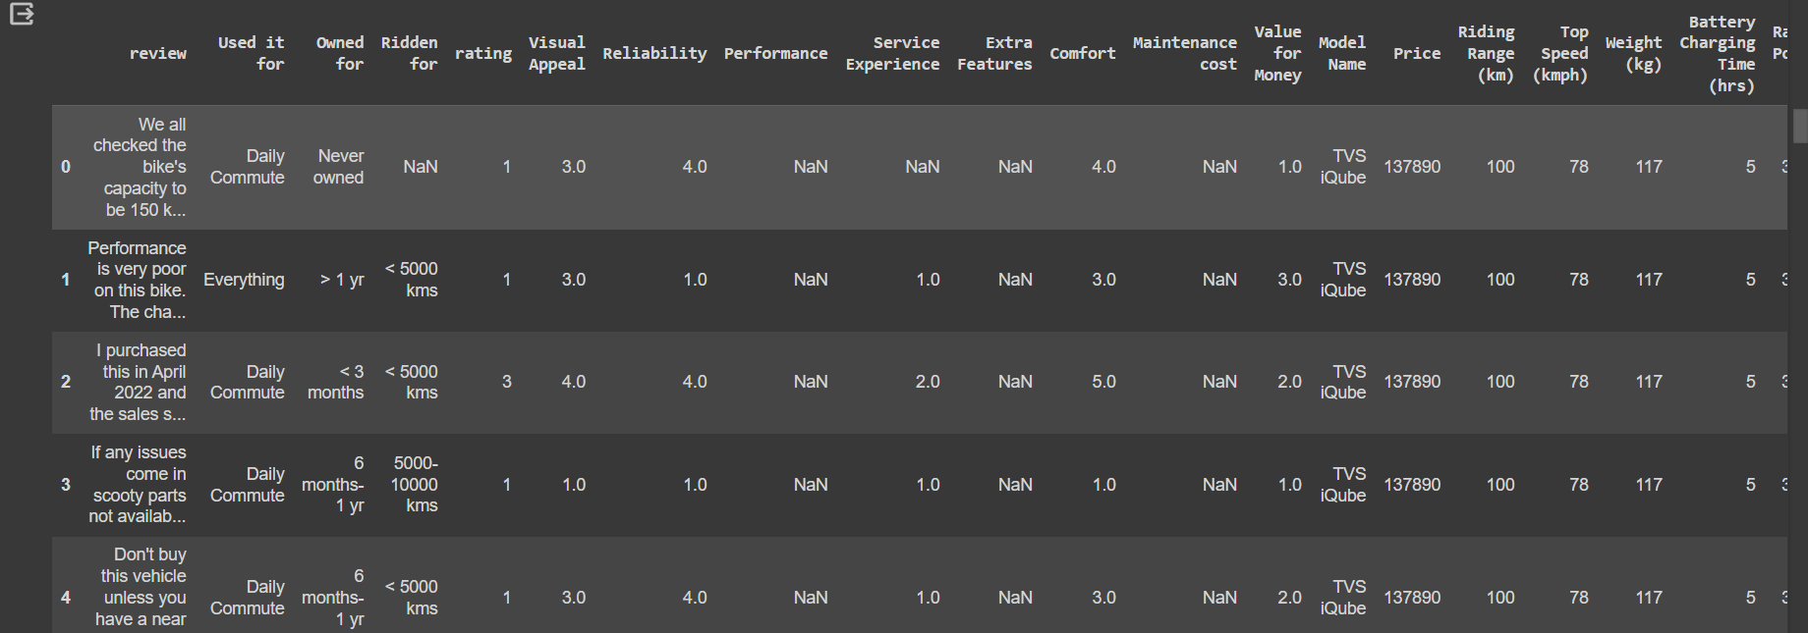

|  |
| --- |

# Profiling Segments

| data_profile = data_segment.copy() data_profile['cluster'] = kmeans.labels_ |
| --- |

| columns_segment = data_clust.columns data_pivot = data_profile[columns_segment].groupby('cluster').mean().T |
| --- |

| data_pivot_mean = data_pivot.mean(axis = 1).reset_index() data_pivot_mean.columns = ['Variable', 'Value'] |
| --- |

| plt.figure(figsize = (12, 9)) for i in range(4):  plt.subplot(2, 2, i+1)  sns.barplot(data_pivot, x = i, y = data_pivot.index)  sns.scatterplot(data_pivot_mean, x = 'Value', y = 'Variable', color = 'red')  for index, row in data_pivot_mean.iterrows():  plt.hlines(y=row['Variable'], xmin=0, xmax=row['Value'], colors='red', alpha = 0.2)  plt.ylabel("")  plt.xlabel("")  plt.title(f"Cluster {i}: {data_profile['cluster'].value_counts()[i]} ({data_profile['cluster'].value_counts()[i]*100/len(data_profile):.0f}%)") plt.suptitle("Segment profile plot for the four-segment solution for the EV 2-Wheeler data set", fontsize = 15) plt.tight_layout() plt.show() |
| --- |

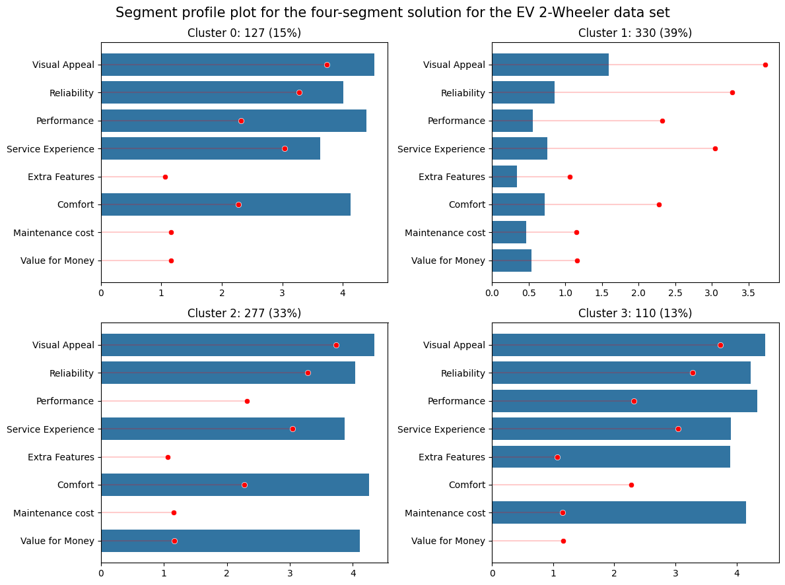

Above graph visually captures the diverse perceptions among different segments. Segment 0, representing 15% of consumers, values the electric two-wheeler vehicle for its visual appeal, reliability, performance, service experience, and comfort. Conversely, Segment 1 (39% of consumers) expresses dissatisfaction across all aspects, marking them as the largest but least satisfied group. Segment 2 (33% of consumers) appreciates visual appeal, reliability, service experience, comfort, and notably, perceives a strong value for money. Lastly, Segment 3 (13% of consumers), the smallest segment, values visual appeal, reliability, performance, service experience, extra features, and maintenance cost, showcasing distinct perceptions, particularly on features and costs.

| # Calculate centroid index_names = factor_loadings.index  # Plot data points sns.scatterplot(data_pca, x = 'PC1', y = 'PC2', hue = 'cluster', palette = 'tab10')  # Plot arrows from centroid to provided coordinates with index names for i in range(len(factor_loadings['PC1'])):  plt.arrow(0, 0, factor_loadings['PC1'][i] * 3.5, factor_loadings['PC2'][i] * 3.5, head_width=0.05, head_length=0.1, fc='red', ec='red')  plt.text(factor_loadings['PC1'][i] * 3.5, factor_loadings['PC2'][i]* 3.5, index_names[i], fontsize=12, ha='center', color = 'red', va = 'center_baseline')  # Set labels and legend plt.xlabel('PC1') plt.ylabel('PC2') plt.title('Segment separation plot using principal components 1 and 2') plt.grid(True) plt.show() |
| --- |

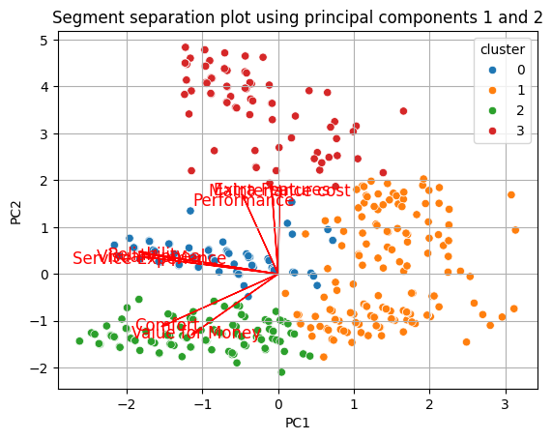

Above Figure, utilizing principal components, further emphasizes the differences among segments. Notably, Segment 1, despite being the largest segment, lacks specific opinions, making them unique in their lack of satisfaction.

# Selection of Target Segment

The strategic target segments for the electric vehicle market are identified as Segment 1 (39% of consumers) and Segment 2 (33% of consumers). Segment 1's diverse preferences and dissatisfaction points present an opportunity for improving customer satisfaction and loyalty by directly addressing their specific demands. Segment 2 values visual appeal, reliability, service experience, and comfort, offering a chance to customize electric vehicles to meet these expectations and emphasize value for money. The strategy involves addressing dissatisfaction points in Segment 1 and enhancing positive elements in Segment 2, aligning electric vehicles with the distinct expectations of each segment to ensure competitive advantage and sustained market growth.

**Source Files & Dataset Links**

**Dataset:**

[**https://docs.google.com/spreadsheets/d/18V83UQl2deX0k_3L64bVgTDDKFpb7z_r/edit?usp=sharing&ouid=104767264485171282754&rtpof=true&sd=true**](https://docs.google.com/spreadsheets/d/18V83UQl2deX0k_3L64bVgTDDKFpb7z_r/edit?usp=sharing&ouid=104767264485171282754&rtpof=true&sd=true)

[**https://drive.google.com/file/d/1LmcCPwGNeXXqMCu7W6EggbWvZF7DgKPO/view?usp=sharing**](https://drive.google.com/file/d/1LmcCPwGNeXXqMCu7W6EggbWvZF7DgKPO/view?usp=sharing)

[**https://drive.google.com/file/d/1Tha6UGBaYNN5UBmLXJYGJN3q7rNVoASC/view?usp=sharing**](https://drive.google.com/file/d/1Tha6UGBaYNN5UBmLXJYGJN3q7rNVoASC/view?usp=sharing)

**Source File :**

[**https://colab.research.google.com/drive/1NgZyQEBlqPk43aoU2WENqqRQNT9H7VMS?usp=sharing**](https://colab.research.google.com/drive/1NgZyQEBlqPk43aoU2WENqqRQNT9H7VMS?usp=sharing)